Brake Shear House Planning Brief

PLANNING BRIEF

BRAKE SHEAR HOUSE SITE

Adopted March 2016

1

Brake Shear House Draft Planning Brief

- INTRODUCTION Purpose and Objectives

1.1 The development of land at Brake Shear House presents a significant opportunity to deliver a mixed used development on a complex and constrained site in Chipping Barnet. Currently occupied by a variety of commercial uses, this draft Planning Brief provides the vision for the future transformation of this site, the majority of which is within Chipping Barnet Town Centre.

1.2 The Council adopted The Spires Planning Framework in July 2012. The framework provides an outline of the vision for the planning of three sites in or on the edge of Chipping Barnet Town Centre. These are the Spires Shopping Centre, Barnet Market site and the Territorial Army site. It provides detailed guidance to manage future development and other improvements to the town centre to ensure long term vitality and viability. Land at Brake Shear House was not identified in the 2012 Planning Framework.

1.3 The Town Centre Strategy for Chipping Barnet was adopted in June 2013. The Strategy provides a framework to protect what is best about Chipping Barnet, setting parameters for high quality expansion of the town centre. It helps to guide and manage future development and change, promote improvements to ensure the town centre's long term vitality and viability and is a material planning consideration in the determination of future planning applications within the town centre.
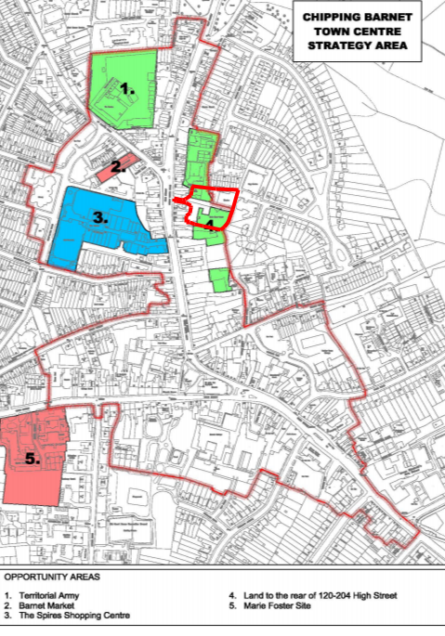

Figure 1: Chipping Barnet Town Centre Strategy Map

2

Brake Shear House Draft Planning Brief

1.4 The Chipping Barnet Town Centre Strategy goes beyond the adopted Spires Planning Framework in focusing on the wider issues facing the town centre including:

•Improving the mix of land uses, primarily for shops (at ground floor level) but also residential, leisure, employment and community uses;

•Improving public transport and pedestrian and cycle connections; •Improving quality of buildings and public spaces; •promoting a safer and more secure environment;
•creating a clear role for the town centre in respect of planned growth elsewhere such as at Brent Cross

1.5 The plan below shows the area covered by the Planning Brief. For the purposes of this Planning Brief the site will be referred to as the Brake Shear House site, even though the above buildings are also included in the site boundary.

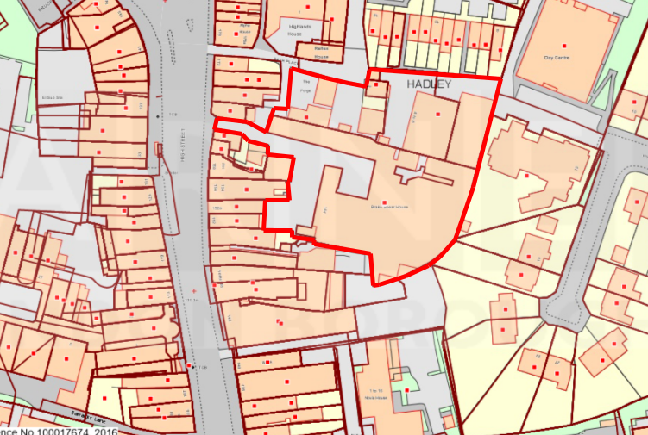



Figure 2: Application site boundary

2.0 EXISTING SITE

Site History

2.1 The majority of the site lies within the boundary of Chipping Barnet Town Centre in the North East of the borough. The High Street, behind which the site lies, consists of commercial and residential properties which date back to the Victorian times. There have been light industrial workshop uses on this site since the mid-19th century. Historically this has included a photo-engraving works and details of the historic uses and development of Chipping Barnet is outlined in the Chipping Barnet Town Centre Strategy. The site falls within the Chipping Barnet Area of Special Archaeological Significance.

3

Brake Shear House Draft Planning Brief

Built Character of Chipping Barnet

2.2 The streetscape in Chipping Barnet generally follows a linear form with relatively well connected streets which stem from the main primary routes through the area: Wood Street and the High Street. This aerial map below shows the site (outlined in red) in relation to the surrounding context of residential terraced and semi-detached housing and street grid layouts. The High Street shows the tight grain of predominantly Victorian townscape which reflects the original medieval burgage plots which originally lined the main route. The Spires shows a departure from the scale, massing and grain of surrounding townscape through the development of the shopping centre and associated car park.
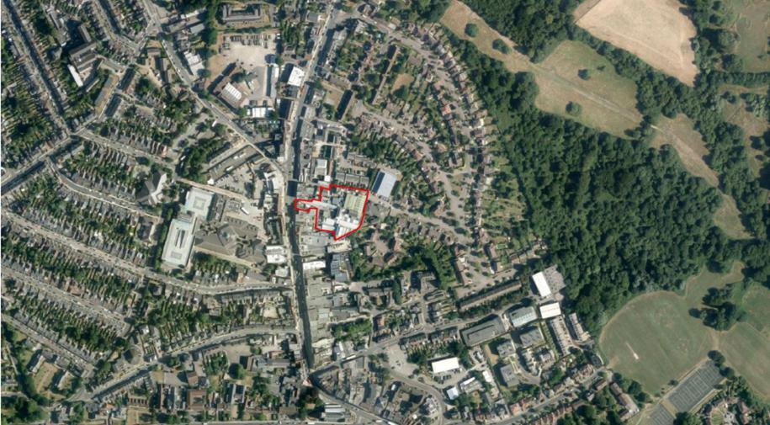

Figure 3: Aerial Photograph of Chipping Barnet (site outlined in red)

Below are historic maps showing the development of the site and its direct surroundings:

4

Brake Shear House Draft Planning Brief
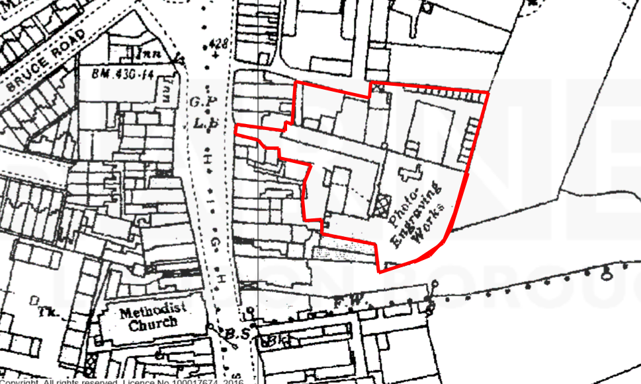

Figure 4: OS Map showing Brake Shear House site 1896-1898
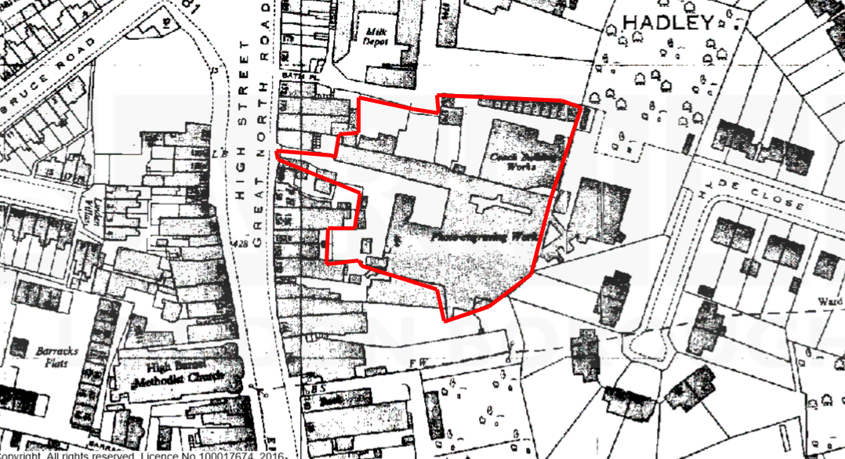

Figure 5: OS Map showing Brake Shear House site 1951-71

2.3 A review of the maps above has shown that the historic High Street has remained largely unchanged over the past 150 years. Brake Shear House dates back to the late Victorian period. Although it has been subject to extensions, re-development and external alterations it still represents a heritage asset although it is not designated. The Brake Shear House footprint today is very similar to how it was in the late 19th Century. However, how this building appears now is a result of several changes to its use and physical appearance over this period of time, although there is limited record of these alterations. The site has been owned by PCDFIII (Barnet) LLP since summer 2015.

5

Brake Shear House Draft Planning Brief

2.4 The site lies opposite the recently redeveloped Spires Shopping Centre which lies to the west of the High Street. This has an important role in providing retail services to Chipping Barnet while the Brake Shear House site provides a range of ancillary works which support the Chipping Barnet Town Centre. These include print works, picture framing and car repairs. Brake Shear House, with other rear of High Street sites, provides non-retail employment which enhances the town centre and its viability and vitality.

2.5 In terms of land adjoining the site, key changes have mainly included the construction of residential properties. This includes Hyde Close to the east, which was constructed in the 1930s and consists of pairs of semi-detached dwellinghouses. A more recent adjoining residential development has been Belgravia Close to the north which received planning permission in 1997 (planning reference N01054X). This development consisted on 23 two to three storey terraced and semi-detached buildings built in a Georgian style. The most recent residential development has been Novia House to the south of the site which received planning permission in 2008 (planning reference B/04315/08). Novia House is a part three, part four storey block of flats consisting of 300sqm of B1 office space, 16 residential units and 21 car parking spaces on a 0.17 ha site which lies to the rear of No. 128-140 High Street.

2.6 The site was identified within the 2006 UDP Schedule of Proposals as part of ‘Land at the Rear of 120 to 124 High Street, Chipping Barnet’. This supported a mixed use scheme of business, retail and residential.

3 PLANNING POLICY FRAMEWORK

3.1 The Barnet statutory development plan is the 2012 Local Plan Core Strategy and Development Management Policies, alongside the 2015 London Plan (consolidated with alterations since 2011). Regard has to be paid to the National Planning Policy Framework (NPPF) when making any decisions on a planning proposal. The key policy issues relevant to the site are town centres, employment, housing and design. These are summarised below.

Key Planning Policy Issues: Town Centres

3.2 Chipping Barnet is identified in the London Plan as a District Town Centre. This is defined as ‘distributed more widely than the Metropolitan and Major centres, providing convenience goods and services for more local communities and accessible by public transport, walking and cycling. Typically they contain 10,000–50,000 sq.m of retail, leisure and service floorspace. Some District centres have developed specialist shopping functions’. The London Plan also identifies Chipping Barnet as having medium growth potential. This ‘includes town centres with moderate levels of demand for retail, leisure or office floorspace and with physical and public transport capacity to accommodate it.’

3.3 The NPPF states that local authorities should recognise that ‘residential developments can play an important role in ensuring the vitality of centres’ and should ‘encourage residential development on appropriate sites.’

6

Brake Shear House Draft Planning Brief

3.4 Policy CS1: Barnet’s Place Shaping Strategy – protection, enhancement and growth – the three strand approach identifies Chipping Barnet as a priority town centre and therefore a location to ‘promote mixed use development in accordance with the place making policies set out within the Core Strategy’.

3.5 Policy CS6: Promoting Barnet’s Town Centres highlights that the Local Authority will realise development opportunities for Chipping Barnet and pursue individual planning objectives as set out in the Chipping Barnet Town Centre Strategy. This policy also states that the Local Authority will ‘promote successful and vibrant centres throughout Barnet to serve the needs of residents, workers and visitors and ensure that new development is of an appropriate scale and character for the centre in which it is located’. This policy also identifies that there is not the need to plan further convenience goods provision before 2026 although the Local Authority aims an additional 16,800sqm (net) of comparison goods floorspace across Barnet by 2021-2026.

3.6 DM11: Development principles for Barnet’s town centres state ‘Appropriate mixed use re-development will be expected to provide re-provision of employment use, residential and community use.’

3.7 Map 4 of the Chipping Barnet Town Centre Strategy document (as replicated on Page 2 of this brief), identifies the site as falling within Opportunity Area 4 – Land to the rear of 120 – 204 High Street. The reference of this site within this policy document indicates the Council’s awareness of the site and its potential to add vitality to the town centre.

Key Planning Policy Issues: Employment

3.8 Policy 4.3 of the London Plan states that ‘mixed use development and redevelopment should support consolidation and enhancements to the quality of the remaining office stock in the types of strategically specified locations identified in paragraph 4.12 ‘

3.9 CS8: Promoting a strong and prosperous Barnet states that Barnet will encourage ‘new mixed use commercial floorspace in our priority town centres (Edgware, North Finchley, Finchley Church End and Chipping Barnet) where access to public transport is good’.

Key Planning Policy Issues: Housing and Design

3.10 ‘CS3: Distribution of growth in meeting housing aspiration’ identifies Chipping Barnet as the ‘main focus for enhancement and infill housing development: and will provide for residential uses above ground floor level’.

3.11 Affordable housing should be provided in line with the Council’s strategic borough-wide target of 40% provision for all new homes. In line with the Core Strategy the tenure mix of affordable housing which will be sought is 60% social rented and 40% intermediate. Viability will be considered in line with the Affordable Housing SPD.

7

Brake Shear House Draft Planning Brief

3.12 A range of unit sizes should be provided to increase the supply of family housing which is a priority in Barnet. The Council’s Housing Strategy recognises the market’s pre-disposition to provide 1 and 2 bedroom units and maintains the priority for family homes across all tenures.

3.13 The NPPF states that new developments should ‘respond to local character and history, and reflect the identity of local surroundings and materials, while not preventing or discouraging appropriate innovation’. The NPPF also states that new developments should be ‘visually attractive as a result of good architecture and appropriate landscaping’.

4.0 DESIGN PARAMETERS

Site Characteristics

4.1 The site covers 0.465 hectares in area. The majority of the site falls within Chipping Barnet Town Centre. The site does not lie in a Conservation Area though the northern boundary of the site is close to the Monken Hadley Conservation Area. Approximately 100 metres to the south of the site is the Wood Street Conservation Area. There are no listed buildings on site.

4.2 The site consists of several small buildings, all built within a tight, compact grain consisting of service yards and alleyways between buildings. The service yards are predominantly used for off-street parking. This urban form developed organically. The buildings on site vary in size and design, though the majority are one or two storeys with the exception of Brake Shear House which has three storeys.

4.3 The site is not identified as a locally significant employment site. Furthermore, the site does not contain any buildings of historical interest. The site is identified as being within Flood Zone 1 of the Environment Agency’s Flood Risk Map. None of the trees within the brief area are of sufficient quality for inclusion in a Tree Preservation Order. However, there are a number of trees outside the brief area which are considered to be of high amenity value.

Existing Uses

4.4 The site currently features several commercial uses and some residential premises in ‘The Forge’, Gate House Cottage and Brake Shear House.

4.5 There is a mix of properties within the B use classes providing a range of employment, including vehicle testing and servicing garages, coffee machine repairs, framing and printing shops. A report submitted by Montagu Evans states that approximately 30 people are currently employed full-time on site in approximately 20 businesses. The total existing B use floorspace amounts to 2606 sqm.

8

Brake Shear House Draft Planning Brief

4.6 This site also includes residential units in ‘The Forge’ and Gate House Cottage on Bath Place and in Brake Shear House. The site is adjoined by a nursery which currently uses the Bath Place entrance as an access. This part of Bath Place adjoins the site boundary.

Surrounding Area

4.7 The majority of the site lies within the Chipping Barnet Town Centre with the exception of the north east part of the site. The site in relation to the town centre boundary is shown on the plan below:
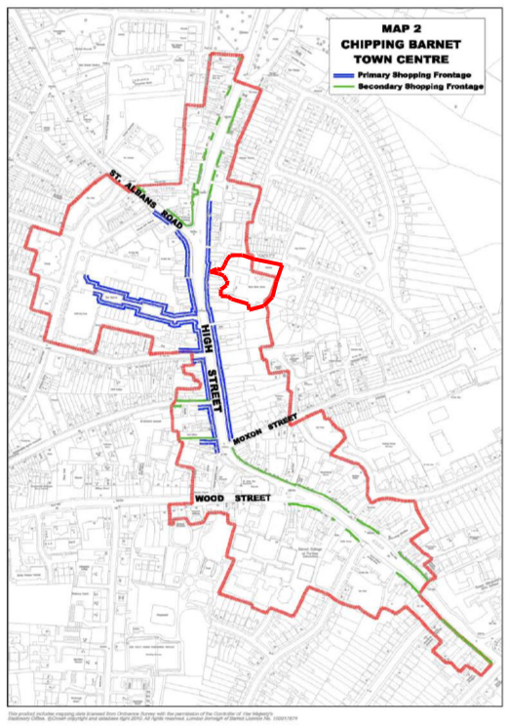

Figure 6: Chipping Barnet Town Centre Map showing retail frontage

4.8 The Monken Hadley Conservation Area adjoins the northern boundary of the site (this is shown on the map below in pink hash).

4.9 The site is adjoined by low density two storey residential housing to the north and east; Hyde Close and Belgravia Close. Both these residential areas are predominantly characterised by dwellinghouses, in pairs of semis or short terraces. Hyde Close also has a two storey block of flats which adjoins the

9

Brake Shear House Draft Planning Brief

north east boundary of the site (No. 12 Hyde Close). This provides residential accommodation for people with physical and learning disabilities.

4.10 The land directly adjoining the southern boundary consists of rear yards serving the high street retail units. The southern side backs onto Novia House, a part three, part four storey block of flats, which was approved in August 2008. This consists of 16 residential units and has a building footprint of 444sqm.
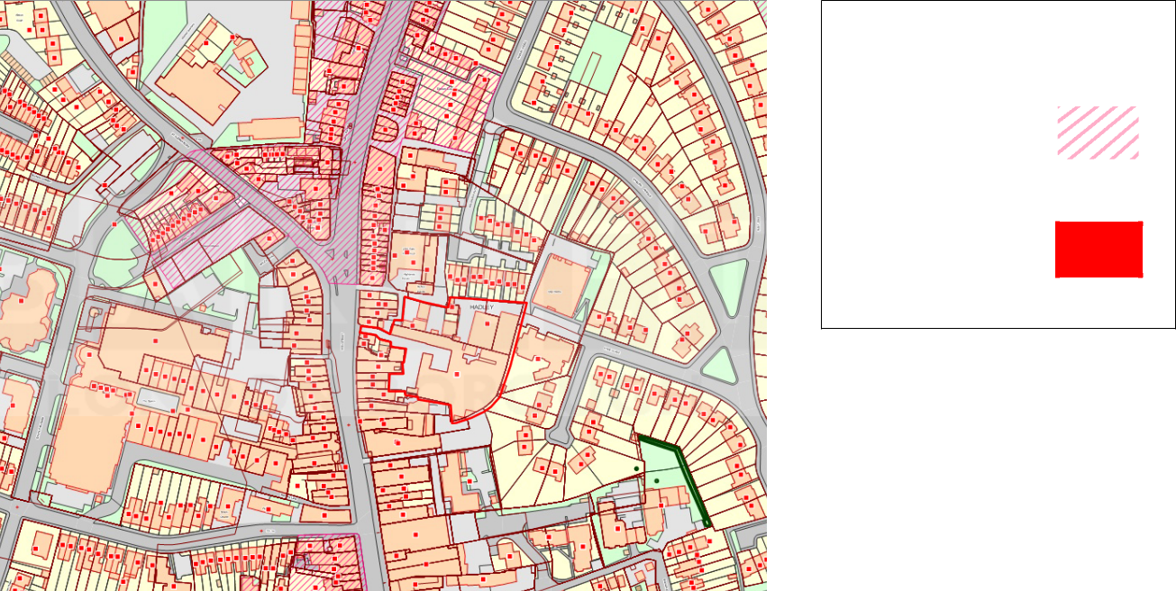

Key

Monken Hadley Conservation Area

Site boundary

Figure 7: Map showing Monken Hadley Conservation Area

Topography

4.11 The application site slopes downhill in an easterly direction by approximately 5 metres. The decrease in levels continues beyond the eastern site boundary across Hyde Close. There is also believed to be a level decrease in a southerly direction across the site. However, no details have been provided to ascertain the extent of this level change.

5.0 OPPORTUNITIES AND CONSTRAINTS

5.1 The following constraints will need to be addressed in any development:

- Levels

- Monken Hadley Conservation Area
- Constrained site permeability
- Potential impact on High Street
- Chipping Barnet Area of Special Archaeological Significance

Levels

10

Brake Shear House Draft Planning Brief

5.2 The level changes across the site are significant and will require careful consideration with regards to building heights, acceptable accesses and location of amenity spaces. The change in levels does provide the opportunity for sub level parking. However, the level difference between the site and neighbouring Hyde Close may act as a constraint to development if any proposal has a detrimental impact on the adjoining residential units in terms of an overbearing impact or loss of privacy. It is likely that set off distances will need to be established between proposed built development and the boundary with Hyde Close to mitigate detrimental impacts of the development. The extent of the set-off distance will be dependent on the height and mass of the proposed built development.

Monken Hadley Conservation Area

5.3 Although the site does not fall within a conservation area, the northern side is close to the Monken Hadley Conservation Area. Any proposed development will need to have due regard to the character and appearance of this conservation area and must not have a harmful impact on views of the conservation area and its setting.

Site Permeability

5.4 There are three access points into the site. These are through narrow alleyways at Bath Place and the High Street. As the adjoining High Street units are classified as Primary Retail Frontages, it is unlikely that the loss of these units to provide additional entrances or to widen the existing entrances would be accepted, with the exception of the loss of No. 162 High Street. The level difference on the eastern part of the site would make it difficult to create an entrance on this side of the site. However, the local authority would not be opposed to reviewing the introduction of a new entrance to this site if it could be shown that this would work with the existing levels and would not have a detrimental impact on Hyde Close.

Impact on the High Street

5.5 Any intensification of the use of the site or introduction of other uses may result in significant additional trip generation and conflicting movements due to right turning vehicles in and out of the site. This would also have a detrimental impact on the existing Pelican Crossing on the High Street close to the site access. A right turning lane may be needed on the High Street, on the approach to the proposed new access for the development to accommodate right turning movements into the site. However, it is considered that the existing Pelican Crossing is located in the prime location to cater for the pedestrian desire line and therefore cannot be relocated. Also the High Street in this location is not wide enough to accommodate a right turning lane. Due to the proximity of the proposed access to the existing Pelican Crossing and the limited width of the road there are no prospects of providing such measures to facilitate the introduction of right turning lanes on the High Street. In the event of an application, it would have to be demonstrated that any increase in the

11

Brake Shear House Draft Planning Brief

number of trips in the vicinity of the site resulting from an intensification/change of use could be accommodated in the existing highways network.

5.6 The High Street is part of a Strategic Road Network and a distributor road. Consideration also needs to be given to the existing location of the bus stop to the north of the proposed access. Any obstruction of the High Street in this location will have a detrimental impact on the movement of buses. Therefore any proposal which is likely to impact on the High Street will need to be referred to Transport for London (TfL).

Chipping Barnet Area of Special Archaeological Significance

5.7 The site falls within the Chipping Barnet Area of Special Archaeological Significance. This is particularly due to the proximity of the site of the Battle of Barnet and possible evidence for the history of Barnet in mediaeval and early modern times. The site is therefore subject to Policy DM06e of Barnet’s Development Management Policies Document (September 2012). Any development on this site will therefore have to be considered by the Council with the advice of the Greater London Archaeological Advisory Service for the imposition of an archaeological condition. Furthermore, to comply with the NPPF and Barnet Local Plan archaeological policies, any planning application submitted would need to be accompanied by an archaeological desk-based assessment which should include consideration of the site’s recent built and industrial heritage.

- RELATIONSHIP WITH SURROUNDING AREA Adjoining Sites

6.1 The site shares its boundaries with low density suburban residential estates to the north and east. The boundary is generally formed by residential back garden fences with houses set back from the boundary by between 7 to 23 metres. The Brake Shear House building directly abuts the eastern and most of the southern boundary with no set off distances. This presents a poor relationship with these residential units and any proposed development should seek to improve separation along this boundary as well as introducing high quality boundary treatments and screening.

6.2 Bath Place and an area of hard surfacing for car parking separates existing buildings from adjoining neighbours to the north. To the west, the site abuts the rear boundary of High Street. There are few boundary treatments separating the site from the rear of these commercial High Street units and any proposal will need to introduce high quality boundary treatments here in order to safeguard the amenities of future residents.

6.3 There are currently three accesses to the site. These entrances are from the High Street to the west of the site. Two of these (identified in blue below) are vehicular although only allow single lane traffic. The third provides pedestrian access only (identified in green). The plan below shows the existing entrances:

12

Brake Shear House Draft Planning Brief
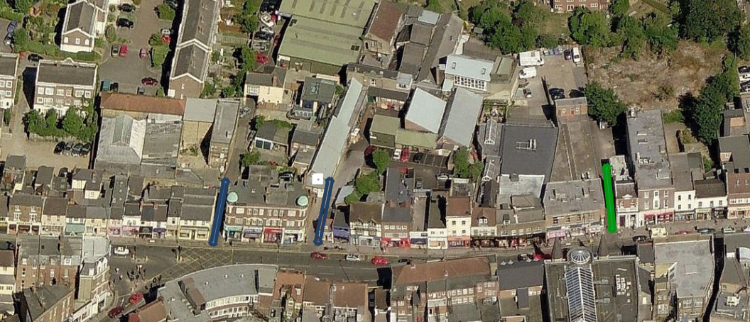

Figure 8: Aerial image showing existing accesses

6.4 Subject to a transport assessment these entrances may be widened to provide a two lane access. There are no routes through the site in a north-to-south direction.

Connectivity

6.5 The site has a PTAL rating of 3. There is a bus stop directly outside the site on the High Street which is served by bus routes 84, 84A and 339. These buses go to St Albans, Potters Bar, South Mimms, Leytonstone, Stratford City, Stepney High Street and Shadwell Station and run approximately every 15 minutes. The nearest underground station is High Barnet which is 0.5 miles from the site (approximately ten minutes’ walk away).

6.6 Due to the suburban location of the site, any development will be expected to provide parking in line with Local DM standards.

- APPROACH TO REDEVELOPMENT Land use

7.1 The majority of B1 units appear to be occupied, which would suggest that there

is a demand for the existing employment space on the site. However, it is recognised that due to the organic development of uses, the existing layout is not space efficient. There is an opportunity to simplify the layout of the site to allow more efficient use of space. Despite the comparatively high level of employment floorspace, according to a Montagu Evans report only 31 people are employed on-site. It is considered that for this level of employment floorspace, a higher number of employees could be accommodated on site. Although all units are occupied, the low number of employees occupied by the existing footprint is not considered to represent efficient use of employment floorspace. It is considered that the redevelopment of the site could address this issue and any development would need to provide enough floorspace to allow for at least the existing levels of employment.

13

Brake Shear House Draft Planning Brief

7.2 The introduction of new flexible B1 floorspace would be encouraged as this would allow comparatively high levels of employment per unit of space. Through supporting the provision of modern business space suited to the needs of small and medium enterprises the Planning Brief also helps to deliver the objectives of Barnet’s Economic Strategy (Entrepreneurial Barnet) in facilitating business growth. However, due to the history of workshop and light industrial uses on this site, it would be expected that some workshop provision should also be made to continue the uses on site (use class B1(c)). The affordability of new employment space within the site is an important issue The Council is keen to promote the provision of affordable workspace on the site, if this isn’t possible, rates will need to be comparable with other similar uses within Chipping Barnet town centre.

7.3 Within the existing site there are already 4 residential properties. In addition, there are residential properties adjoining the north, east and south boundaries of the site. Due to the presence of residential properties on site and in the surrounding area, the principal of residential development is acceptable, subject to compliance with other relevant policies and standards and subject to satisfactorily re-providing B employment space on site.

7.4 Due to the site’s location to the rear of primary retail frontage, the introduction of retail uses to this site would be resisted by the Local Authority, as this use in this location would draw activity away from the High Street. Any proposed retail uses on this site would fall outside the ‘retail triangle’ identified in map 6 of the Chipping Barnet Town Centre Strategy. Furthermore, it is anticipated that the high number of vehicles entering and leaving the site would have a detrimental effect on vehicle movement on the High Street, particularly due to the difficulties of introducing a right-turn lane.

Urban Form and Character

7.5 The urban form of the development would need to reflect the existing grain of the site and the small plot pattern of the surrounding area. Developments are encouraged to use creative and innovative layouts to allow better use of the site space and to create a more attractive environment. The prospect of providing mews style housing would be supported by the Council. It is considered that this style of building would reflect the nature and character of the site and the organic pattern of development in and around the site, which generally comprises narrow alleys, low rise buildings, and would represent a scale of dwelling more characteristic of this area. Parking provision should be sensitive to the design of the scheme and some undercroft parking may be acceptable subject to the design of the development.

7.6 The provision of large urban blocks is likely to undermine the permeability of the site and would fail to reflect the existing urban grain of the site and the character of the nearby Monken Hadley Conservation Area. Any proposed flatted development should not have a detrimental impact, in terms of footprint, height, bulk and mass, on the urban character of this part of High Barnet.

14

Brake Shear House Draft Planning Brief

7.7 Any proposed development will need to reflect the design characteristics of the area, including the use of pitched roofs, matching brickwork and other vernacular architectural features.

Routes and Access

7.8 Currently the routes through the site consist of narrow alleyways, which make this space illegible. Redevelopment of the site should seek to improve permeability and legibility and should give consideration to future vehicles, cyclists and pedestrians, while maintaining the tight-knit access design that is present on site and in much of Chipping Barnet. There is the opportunity through redevelopment of the site to improve permeability in a north-to-south direction across the site.

8.0 DETAILS TO BE CONSIDERED

Privacy and overlooking

8.1 Any proposed development should respond to the adjacent residential properties in terms of height and proximity to adjoining boundaries in order to not cause loss of privacy. In new residential development there should be a minimum distance of 21 metres between properties with facing windows to habitable rooms to avoid overlooking, and 10.5 metres to a neighbouring garden.

Outdoor Amenity Space

8.2 Provision of outdoor amenity space is vital in Barnet and a key consideration for new residential developments. Gardens/outdoor amenity spaces make a significant contribution to local character and specifically towards biodiversity, tranquillity, amenity, setting and sense of space.

8.3 Any proposed development will need to meet the minimum outdoor amenity space standards as outlined in Barnet Council’s Sustainable Design and Construction SPD. The siting of this amenity space will need to be carefully considered in terms of the surrounding uses to ensure that proposed amenity space is not overlooked or subject to noise or disturbance.

8.4 The incorporation of high quality soft landscaping into the proposed street scene will be important to ensure visual interest and seasonal diversity of any new development. A key part of this will be the introduction of trees to the site. Soft landscaping will also be important in providing relief and privacy screening and particular attention should be paid to boundaries between business and residential uses. It is recognised that in order to allow a high quality redevelopment with excellent streetscape soft landscaping, refuse and parking measures will need to be considered in detail from the planning application stage rather than being dealt with as a condition. This is in order to better integrate these features into the overall design of the scheme.

Building heights and bulk

15

Brake Shear House Draft Planning Brief

8.5 The height and mass of any proposed buildings must reflect the urban grain of this part of Chipping Barnet. For this reason it is considered that a mews style development would appropriate for this site, as this would reflect the built form of adjoining Belgravia Close and the existing urban grain of the site. Although the site is currently adjoined by a block of flats (Novia House and 12 Hyde Close), flatted development alone would not be considered appropriate as the larger grain resulting from this form of residential development would not be sympathetic to the character of this part of Chipping Barnet. A combination of mews style housing and flatted residential development may be considered appropriate. However, the footprint, mass, height and design of any proposed block of flats would have to be carefully considered in order to be sympathetic to the distinctive character of Chipping Barnet and to avoid detrimental impact on the setting of the adjoining Monken Hadley Conservation Area.

8.6 The existing building heights on the site and adjoining the site do not exceed 2/3 storeys. Therefore proposed buildings will be expected to reflect these parameters, though any proposed increase will need to be located at the centre of the site, away from neighbouring boundaries. Cross section drawings showing views of any proposed development from the High Street and Hyde Close will need to be submitted in the event of an application. A key consideration in the appraisal of any new development is how visible it would be from these two areas as well as surrounding public spaces including the King George Fields. Consideration will have also to be given to the impact of any development on the glimpsed views of the site through Bath Place and other alleyways connecting the site to the High Street.

Relationship to High Street

8.7 Due to the site’s edge of town centre location and proximity to the High Street, the introduction of retail units would not be supported as this could draw activity away from the High Street. The introduction of new accesses to the site should not have a detrimental impact on the functioning and appearance of the High Street. Elevational and cross section drawings will need to be submitted in the event of an application to demonstrate that any proposed development will not be unduly visible from the High Street.

8.8 Careful consideration will need to be given to the siting of proposed residential units in relation to surrounding commercial spaces and their accesses to ensure that there is no detrimental impact on new residential units in terms of noise and disturbance. Details of boundary treatments will need to be submitted at the application stage to ascertain that sufficient screening has been provided between the rear of the High Street commercial units and proposed scheme. In addition, the introduction of gates as a means of controlling entry to the site conflicts with Local Plan policies and would not be supported. Other, more sensitive, forms of access control may be considered at the application stage.

Internet Connectivity

16

Brake Shear House Draft Planning Brief

8.9 Providing the latest internet connectivity in new homes as well as the re-provision of business space will help support both home working trends and meet the needs of small to medium commercial enterprises. Any new development should be supported through high quality telecommunications connectivity. Superfast broadband for example is just one way of benefitting businesses through quicker file sharing, video conferencing, online data storage [reducing hardware costs], all providing a better customer experience. Local wireless connectivity may also be a consideration to support the changing nature of work and small business activity together with the changing nature of community facilities.

9.0 PLANNING APPLICATION REQUIREMENTS

9.1 A full planning application will need to be submitted for the site. This will enable the Council to consider the detailed design issues alongside the general principles of redevelopment, as the two are inter-related.

9.2 The Council has a Validation Checklist, which sets out the national and local requirements for planning applications. The developer, through the pre-application process should engage with the Council’s planning officers to agree the range of documents to be submitted and the scope and standard expected. This will help to ensure that there are no delays in the validation process, and that requests for additional information are minimised once the application has been received.

9.3 Furthermore, early discussions should be held with Council officers on the likely conditions should any application be approved. Where conditions require the submission and discharge of further documents, the scope of those documents should be agreed before they are submitted. This will help with the discharge of conditions.

9.4 The Council’s requirements for consultation on planning applications are set out in the Statement of Community Involvement as adopted in June 2015. The applicant will need to demonstrate that the proposal has undergone significant community engagement in order to consult with different groups within the local community. This will be detailed within the Statement of Community Involvement as submitted with the application.

10 DEVELOPMENT CONTRIBUTIONS

Community Infrastructure Levy

10.1 The purpose of CIL is to pay for infrastructure required to mitigate the impact of development across the Borough. Barnet’s CIL charging rate has been set at: £135 per m². It applies to the ‘net additional floorspace’ of new development which is delivering 100 m² or more of gross internal floorspace or the creation of one additional dwelling. Net additional chargeable floorspace on the Brake

17

Brake Shear House Draft Planning Brief

Shear House site will consist of the additional floorspace over and above the total existing employment floorspace.

10.2 In addition to Barnet’s CIL the Mayoral CIL applies to all chargeable development in the borough. Currently a flat rate of £35 per m² applies.

S106 Requirements

10.3 The items sought through a planning obligation will vary depending on the development scheme and its location. Considerations that may be included in a Section 106 agreement include:

improvements to public transport infrastructure, systems and services education provision

affordable or special needs housing health facilities
small business accommodation and training programmes to promote local employment and economic prosperity
town centre regeneration and promotion

management and physical environmental improvements including heritage and conservation
improvements to highways and sustainable forms of transport environmental improvements
provision of public open space and improving access to public open space including sport pitches
other community facilities including policing other benefits sought as appropriate.

10.4 In accordance with Paragraph 204 of the NPPF and Community Infrastructure Levy Regulations 122, planning obligations should only be sought where they meet all of the following tests:

necessary to make the development acceptable in planning terms; directly related to the development; and

fairly and reasonably related in scale and kind to the development.

10.5 In considering planning obligations, we will take into account the range of benefits a development provides. It will also be important to ensure that the scale of obligations are carefully considered so they do not threaten the viability of development, in accordance with paragraph 173 of the NPPF.

10.6 The extent to which a development is publicly funded will also be taken into account and policy applied flexibly in such cases. Pooled contributions will be used when the combined impact of a number of schemes creates the need for infrastructure or works, although such pooling will only take place within the restrictions of the Community Infrastructure Levy Regulations 2010.

18

Brake Shear House Draft Planning Brief

Appendix 1 - Relevant National, Regional and Local Planning policies

NATIONAL PLANNING POLICIES

National Planning Policy Framework

REGIONAL PLANNING FRAMEWORK

The London Plan 2015

LOCAL PLAN

LB Barnet Core Strategy

LB Barnet Development Management Policies

19

Brake Shear House Draft Planning Brief

Policy Summary Index

 | National Planning
Planning Issue | Policy | London Plan Policy |  | Local Plan Policy
Planning Issue | Framework | London Plan Policy |  | Local Plan Policy
 | (NPPF)
Accessibility | Protecting Sustainable | Policy 7.2: An inclusive |  | Policy DM 3: Accessibility and
 | Transport – | environment |  | inclusive design
 | paragraph 32
Employment | Delivering sustainable | Policy 4.1: Developing London’s |  | Policy DM14: New and existing
 | development - | Economy |  | employment space
 | paragraph 22 | Policy 4.2: Offices |  | Policy CS 8: Promoting a strong and
 |  | Policy 4.10:New and emerging |  | erous Barnet
 |  | economic sectors
 |  | Policy 4.11: Encouraging a
 |  | connected economy
 |  | Policy 4.12: Improving
 |  | opportunities for all
Housing Delivery | Delivering a wide choice | Policy 2.6:Outer London - Vision |  | Policy CS4: Providing quality homes
 | of high quality homes – | and strategy |  | and housing choice in Barnet.
 | paragraph 50 | Policy 2.7:Outer London - economy y |  | DM08: Ensuring a variety of sizes of
 |  | Policy 2.8:Outer London - transport |  | new homes to meet housing need.
 |  | Policy 3.8: Housing Choice
 |  | Policy 3.4:Optimising housing
 |  | potential
 |  | Policy 3.5: Quality and design of
 |  | housing developments
 |  | Policy 3.12: Negotiating affordable
 |  | housing on individual
 |  | private residential and
 |  | mixed use schemes
Heritage and | Conserving and enhancing | Policy 7.4: Local character |  | Policy CS5: Protecting and
Landscape | the historic environment – |  |  | enhancing Barnet’s character to
character | paragraph 126 | Policy 7.8:Heritage assets and |  | create high quality places
 |  | archaeology. |  | Policy DM06: Barnet’s heritage and
 |  |  |  | Conservation
Education | Promoting healthy | Policy 3.18: Education facilities |  | Policy DM14: Community and
 | communities - |  |  | education uses
 | paragraph 72
Environment and | Conserving and enhancing | Policy 2.18: Green Infrastructure – |  | Policy CS7: Enhancing and
Biodiversi | the natural environment – | The multi – functional |  | protecting Barnet’s open spaces
ty | paragraph 109 | network of green and |  | Policy DM 15: Green Belt and open
 |  | open spaces |  | Policy DM 15: Green Belt and open
 |  | Policy 7.19: Biodiversity and |  | Spaces
 |  | access to nature |  | Policy DM 16: Biodiversity
 |  | Policy 7.21: Trees and woodlands
Sports and | Promoting healthy | Policy 3.6: Children and young | y | CS7: Enhancing and protecting
recreation | Communities - paragraph 73 | people’s play and |  | Barnet’s open spaces
 |  | infant recreation
 |  | facilities |  | Policy CS11: Improving health and
 |  | Policy 3.19: Sports facilities |  | well being in Barnet


20

