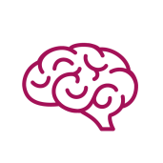
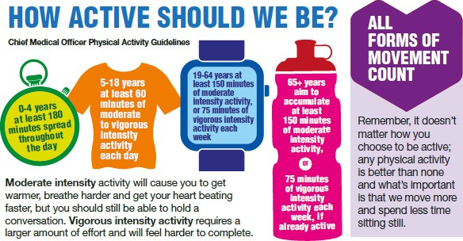
BE MORE ACTIVE
BE FREE

FACTS AND FIGURES
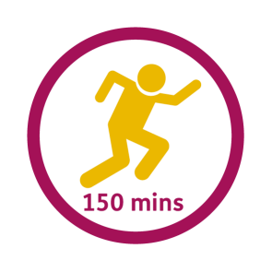
of adults in Barnet participate in 150 minutes of physical activity each week.
71%

Move for your mood
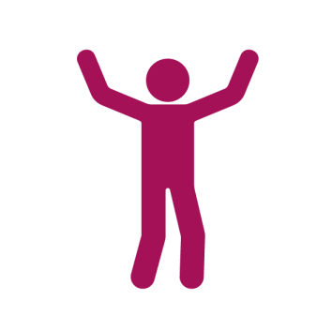
Being active can reduce anxiety, depression and help with sleeping.

Being physically active
Can keep you:
- strong
- mentally fit
- independent as you age
- Reduces risk of certain chronic conditions by 50%
HELP AND ADVICE

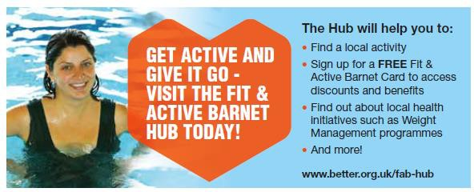
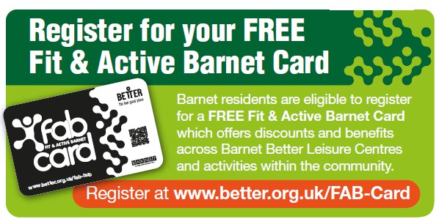
BE MORE ACTIVE
BE FREE

FINDING AN ACTIVITY FOR YOU
There is an abundance of physical activity opportunities available in the borough that will support you to lead a more active and healthy lifestyle.

